North Lincolnshire Council
Daily Event Analysis
22nd October 2010

Overview
The Low Santon TEOM measured a daily mean PM₁₀ concentration of 120µg/m³ on Friday 22nd October 2010 exceeding the allowed 50µg/m³ as a daily mean. The Dawes Lane Coke Oven (DLCO) Osiris measured a daily PM₁₀ concentration of 53μg/m³ also exceeding the allowed 50μg/m³ as a daily mean. A check of the data has revealed that the PM₁₀ concentrations were significantly above the 50μg/m³ threshold between 10:00 and 16:00 at the Low Santon TEOM and fluctuated throughout the same period at the DLCO Osiris. The average PM₁₀ concentration for this time period at the Low Santon TEOM was 250μg/m³ with a peak at 346μg/m³. The DLCO Osiris averaged at 65μg/m³.

Met Conditions
Consistent SW winds were observed throughout the day. The wind within the 6 hour period of focus ranged between 230° and 260°. Wind speeds averaged at 4.0 m/s. Light rain was measured early in the evening and in to the night.

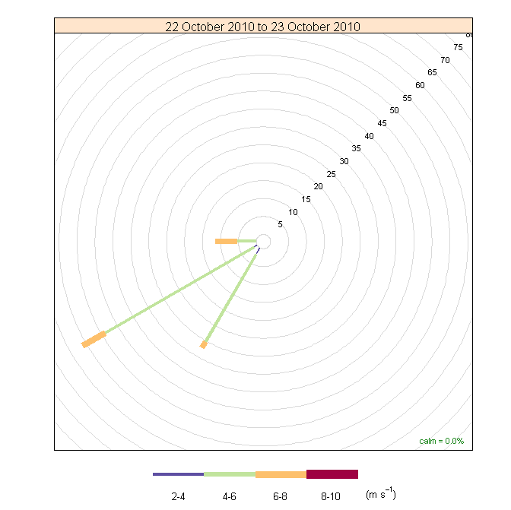

Episode Wind Range

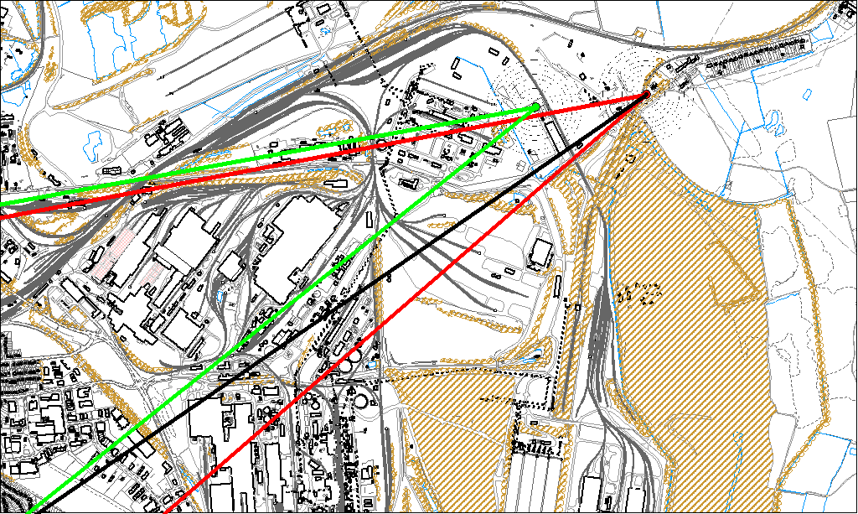

Potential Sources
The above map shows the Low Santon TEOM (indicated by the red lines) and the DLCO Osiris (indicated by the green). The black line within the red shows the wind direction of the highest concentration recorded during the 6 hour period of focus.

As the Low Santon TEOM measured consistently higher concentrations during this period, it is likely that the TEOM was affected by a different source to the DLCO Osiris although the Osiris did exceed the 50μg/m³ threshold for the day. Because of this difference the areas in which the red and green lines intersect are unlikely to be the location of the problem.

The likely areas include;

- The Redbourn Steel Stocking Area
- Tarmac

The black line indicates the highest measured concentration of 346μg/m³ recorded at the Low Santon TEOM during this period. It runs through both the Tarmac site and the Redbourn Steel Stocking Area.

